Crossword
- Use-case Diagram :
- Actor Admin :

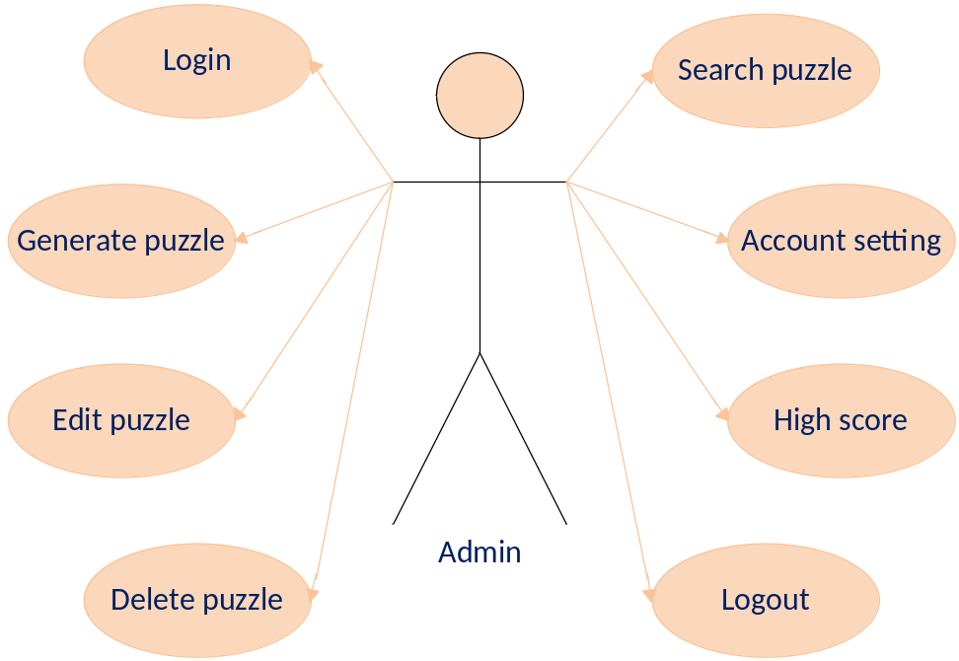
- Actor Player :

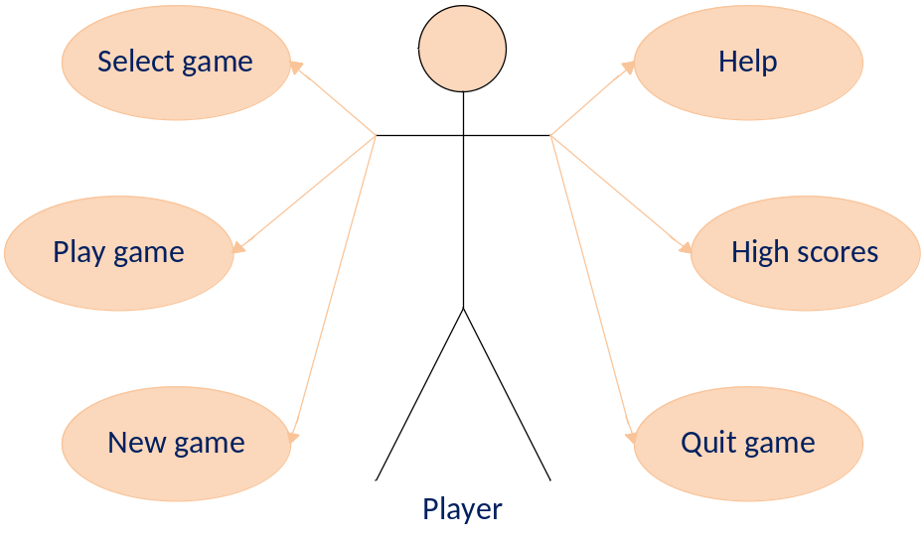

- Use-case Specification :
- List of Actors :
No | Actors | Comment
1 | Admin | Game manager
2 | Player | Those who play

- List of Use-case :
No | Use-case | Comment
1 | Login | Administrator logged into the system
2 | Logout | Administrator exit the system
3 | Account setting | Edit password of Administrator
4 | Generate the puzzle | Create a new puzzle from puzzles bank
5 | Delete the puzzle | Delete a puzzle from puzzle list
6 | Edit the puzzle | Edit a puzzle from puzzle list
7 | Search the puzzle | Find puzzle based on puzzle name or category
8 | high scores ( administrator ) | View high scores of player
9 | New game | Create new game.
10 | Select game | Choice kind of games to play
11 | Play game | Play game.
12 | high scores ( player ) | View high scores of player
13 | Help | Introduce about Game and get some directions to play game.
14 | Quit game | Quit game

- Description
3.1 Use-case “Login” :
Use-case
Summary | Function login allows Administrator login to system with corresponding powers
Major events | Step1: When administrator click manage game button, form login will be displayed  Step 2: Administrator enter their username and password  Step 3: Click button “Login” program will check username and password in database. Click button “Exit to exit this form.  Step 4: If exist program will display a confirmation message “ Login Successful” and manage game form will be displayed. Else program will display a confirmation message “Login Failed” and return Step2.
Other events

3.2 Use-case “Logout” :

Use-case | Logout
Summary | Function “ Logout” help Administrator logout the program
Major events | Step 1: When administrator want to sign out click button “Logout” on the program interface.  Step 2: Program will display a confirmation message “Do you want to sign out ?”  Step 3: If click “Yes” administrator will exit program and disconnect with database. If click “No” administrator will turn back application interface.
Other events

3.3 Use-case “Account setting ” :
Use-case | Account setting
Summary | Function “Account setting” help administrator change password
Major events | Step 1: Click tab “Account setting”, account setting form will be display.  Step 2 : Administrator enter their old password, new password and confirm password.  Step 3: Click button “save” or click button exit to exit this form.  Step 4 : The program will display a confirmation message “Do you want to change password ? ”  Step 5 : click “Yes” the password will be change to the database . Or click “No” to return account setting form.
Other events

3.4 Generate the puzzle :
Use-case | Generate the puzzle
Summary | Function “Generate the puzzle” help administrator create puzzles
Major events | Step 1: Click on tab “Generate the puzzle”  Step 2:
Other events

3.5 Delete the puzzle
Use-case | Delete the puzzle
Summary | Function “Delete the puzzle” help administrator delete puzzles
Major events | Step 1: Click on tab “Delete the puzzle”  Step 2 : choose a puzzle and press button “Delete”  Step 3 : the program will display a confirmation message “Do you want to delete puzzle ? ”  Step 4 : click “Yes” the puzzle will be delete to the database and will be displayed on application . Or click “No” the form will exit .
Other events

3.6 Edit the puzzle
Use-case | Edit the puzzle
Summary | Function “Edit the puzzle” help administrator edit puzzles
Major events | Step 1: Click on tab “Edit the puzzle”  Step 2 : choose a puzzle and edited by Administrator  Step 3: click button “save”  Step 4 : the program will display a confirmation message “Do you want to edit puzzle ? ”  Step 5 : click “Yes” the puzzle will be change to the database . Or click “No” the form will exit .
Other events

3.7 Search the puzzle
Use-case | Search the puzzle
Summary | Function “Search the puzzle” help administrator Search puzzles
Major events | Step 1: Click on tab “Search the puzzle”  Step 2 : enter puzzle name or ID of puzzle then press button “Search”  Step3 : if the puzzle is exists in database : program will display information . Else program will display a confirmation message “No puzzle”
Other events

3.8 high scores
Use-case | View highest scores
Summary | Function “View highest scores” help administrator view , delete Player’s scores .
Major events | Step 1: Click on field “View highest scores”  Step 2 : program show the from “View highest scores”  If Administrator want to delete Player’s scores :  Step 3 : choose a Player’s scores and press button “Delete” .
Other events

3.9 New game
Use-case | New game
Summary | Function “Player name” help Player start a new game
Major events | Step 1: Click on field “New game”  Step 2 : Program will show a new game give Player
Other events

3.10 Select game
Use-case | Select game
Summary | Function “Select game” help Player select a game genre suited for playing
Major events | Step 1: Click on field “Select game”  Step 2 : choose game genre suited for playing
Other events

3.11 Play game
Use-case | Play game
Summary | Function “Play game” help Player play game and show form Scores and answers
Major events | Step 1: Click on empty place  Step2 : enter key word on empty place  Continue Step1 and Step2 elsewhere until player complete .  Step 3 : press button “Submit” it will display form Scores and answers
Other events

3.12 high scores
Use-case | View highest scores
Summary | Function “View highest scores” help Player View highest scores
Major events | Step 1: Click on field “View highest scores”  Step 2 : program show the from “View highest scores”
Other events

3.13 Help
Use-case | Help
Summary | Function “Help” help Player find out game
Major events | Step 1: Click on field “Help”  Step 2 : program show the file “Help”
Other events

3.14 Exit game
Use-case | Exit game
Summary | Function “exit game” help Player exit game
Major events | Step 1: Click on tab “Exit game”  Step 2 : program to stop working and automatically shut down
Other events

- Site Map
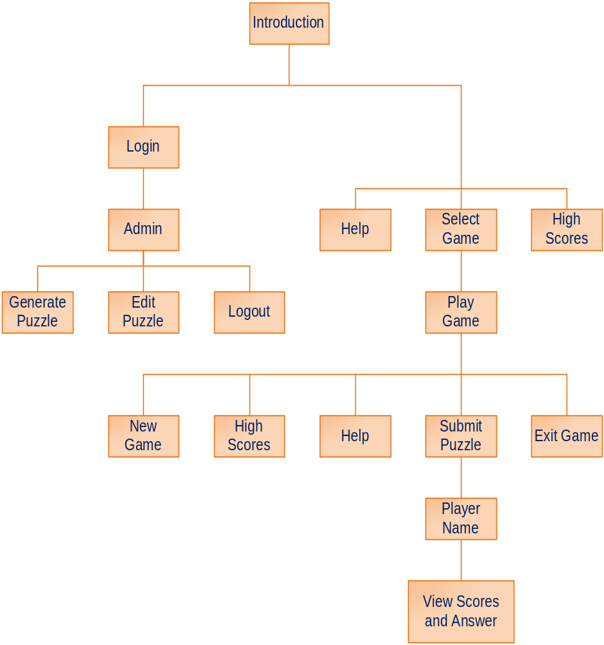

- Flow chart
      - Admin
- Login
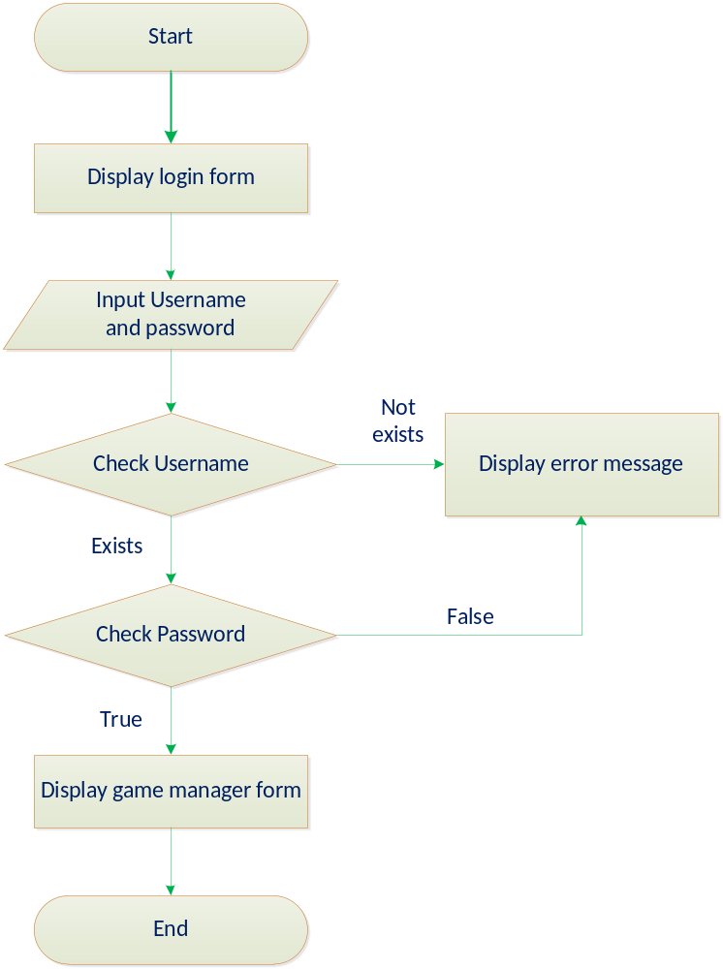

- Account setting
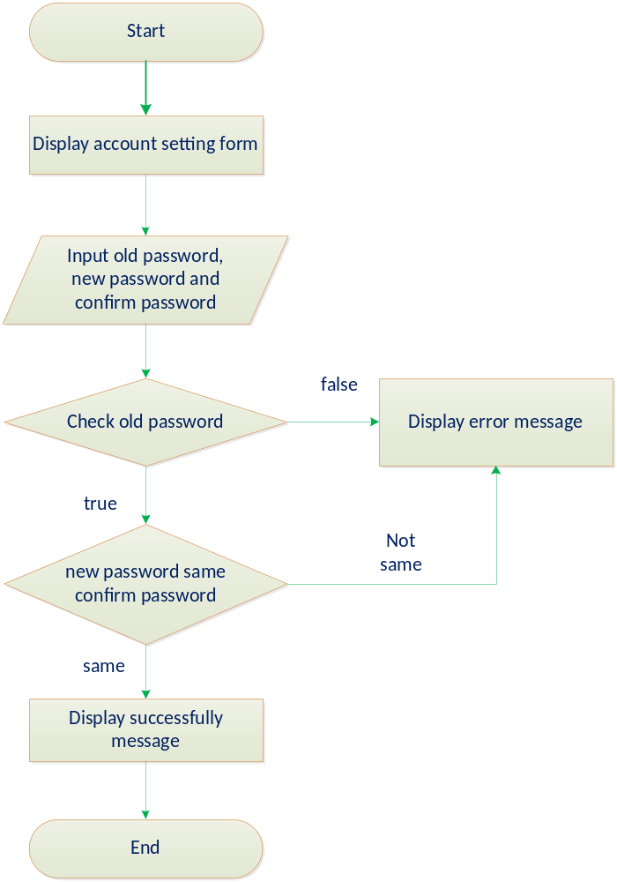

- Generate puzzle
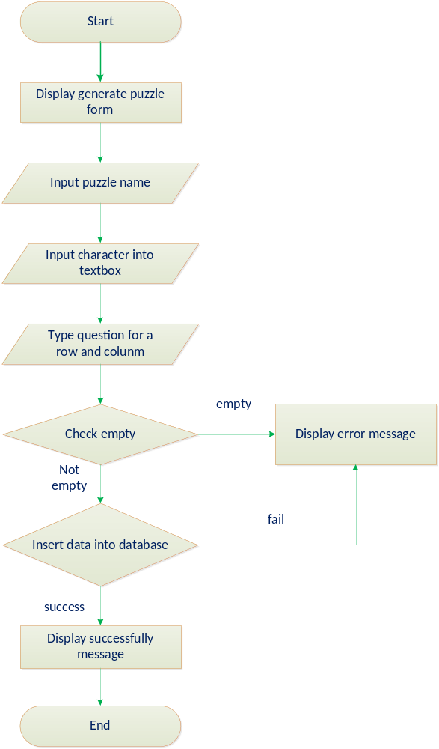
- Delete puzzle
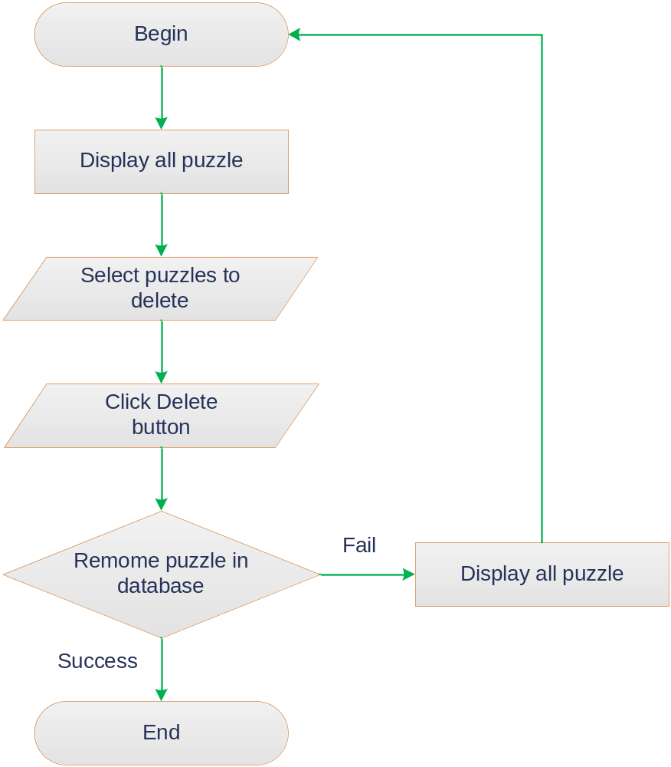

- Edit puzzle
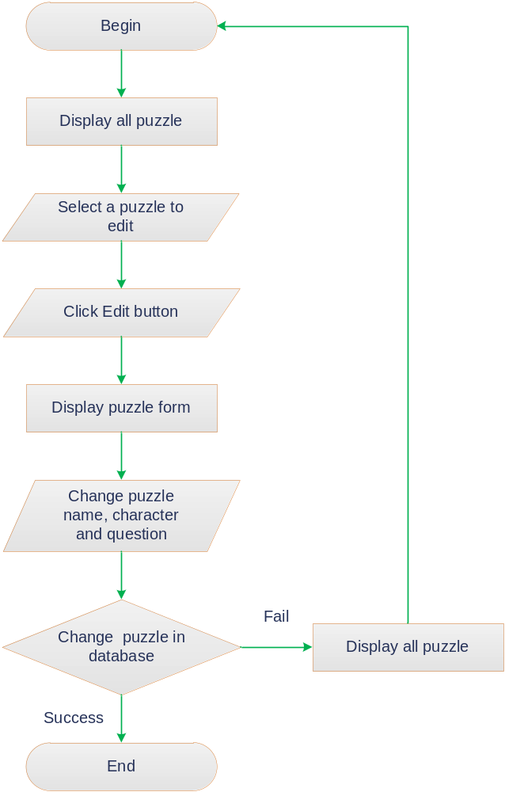

- Search puzzle
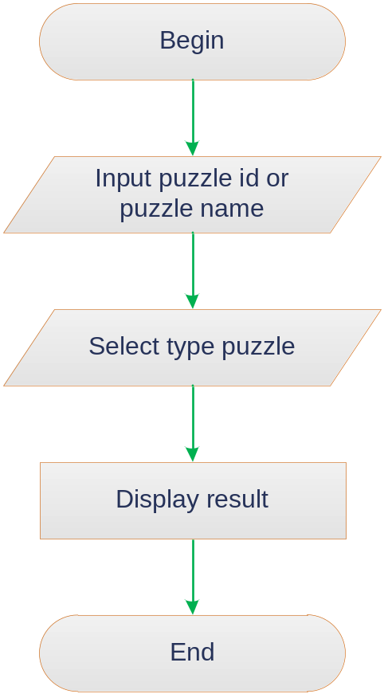

- View high scores
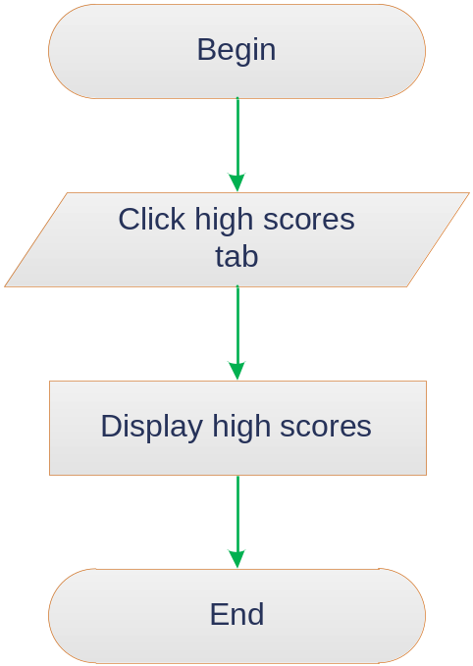
- Logout
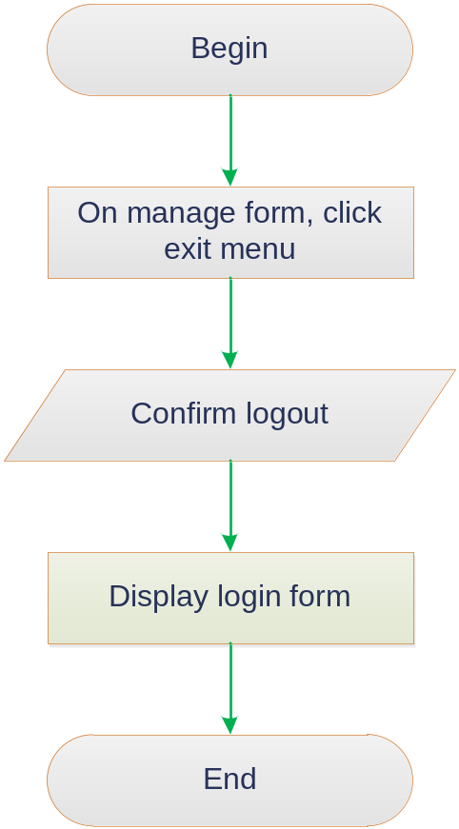
- Player
- New game
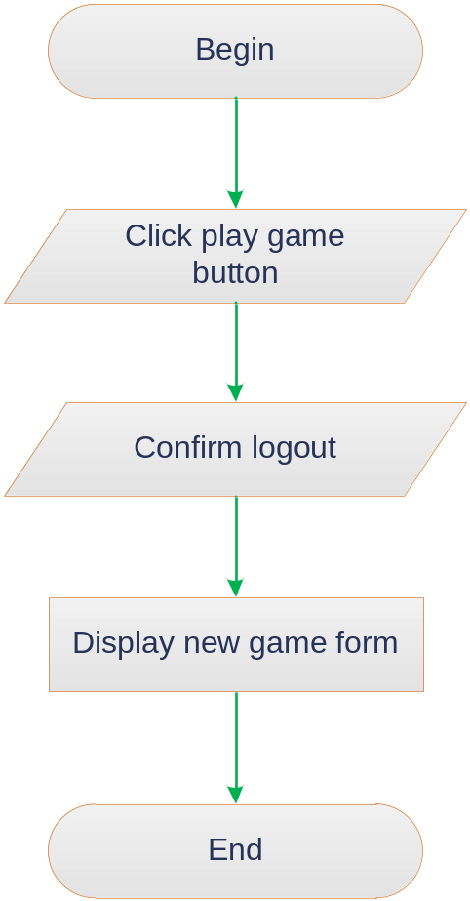

- Select game
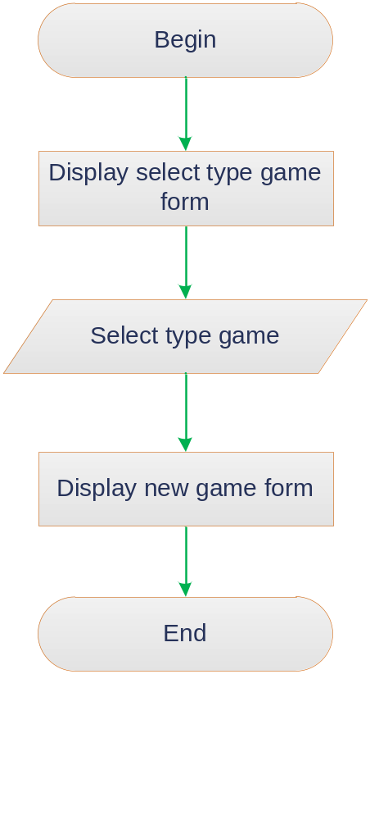
- Play game
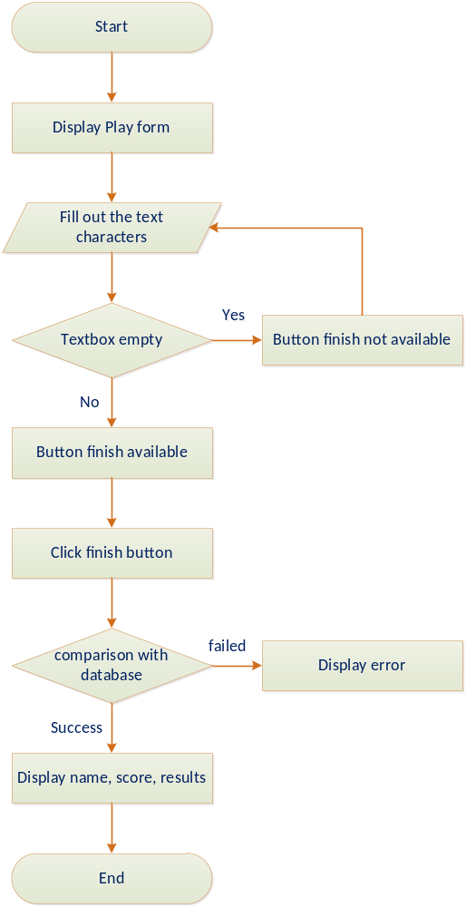
- View high scores
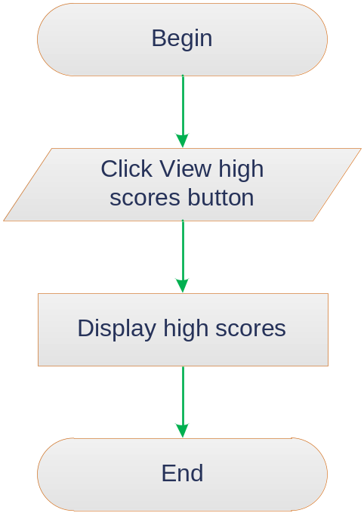
- Help
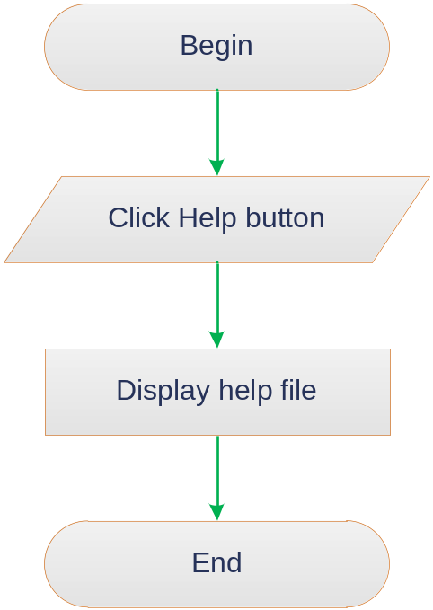

- Exit game
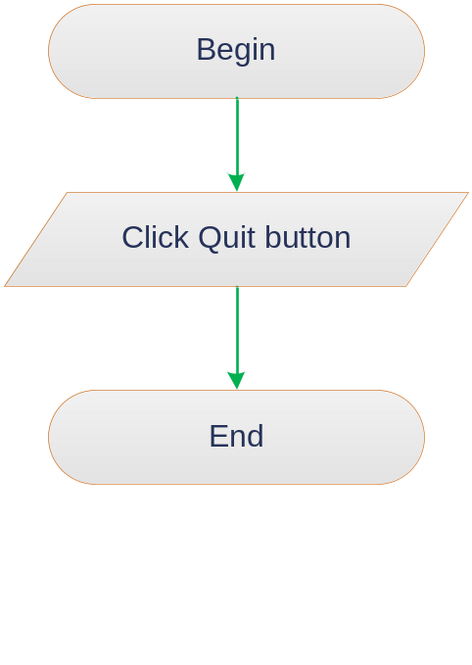
- Layout
      - Connect database
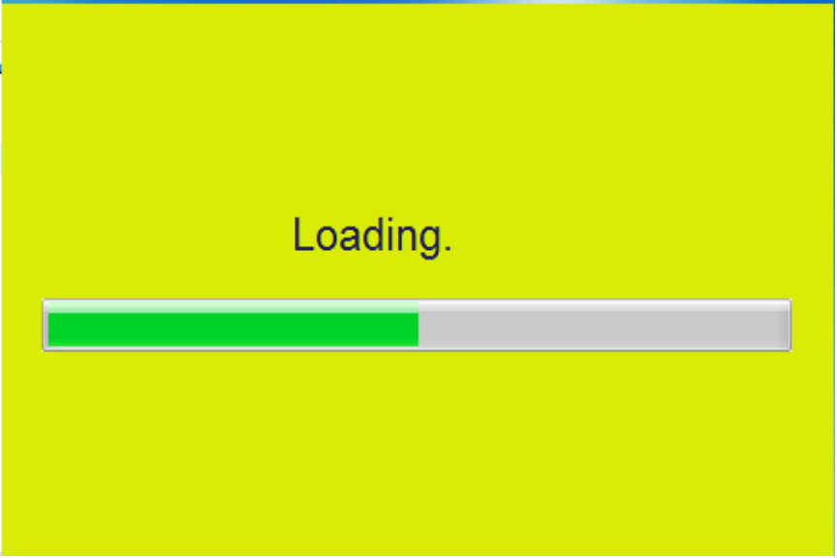

      - Config server
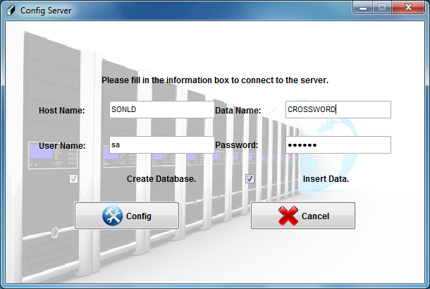
      - Main menu
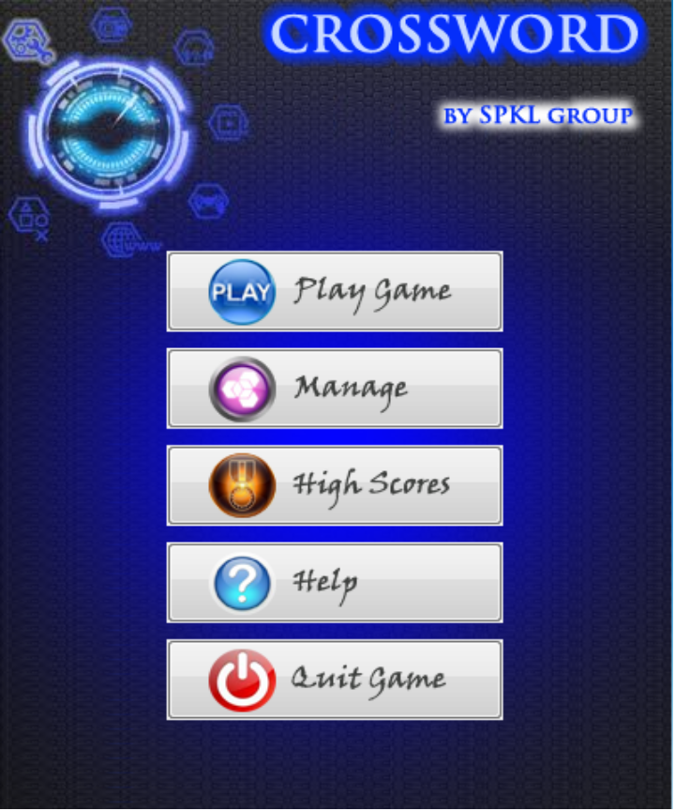
      - Chose type game
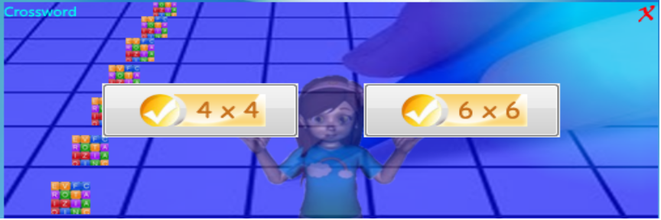
      - Crossword 4 x 4
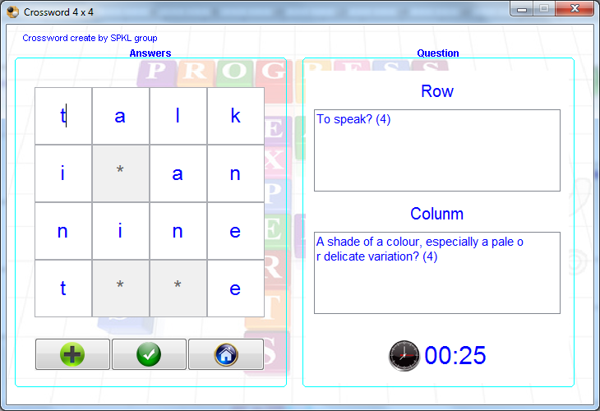

      - Crossword 6 x 6
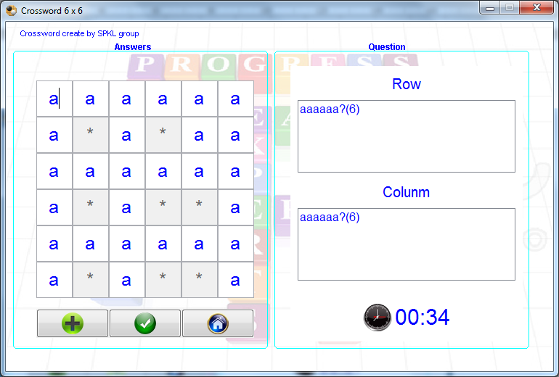

      - Result Play 4x4
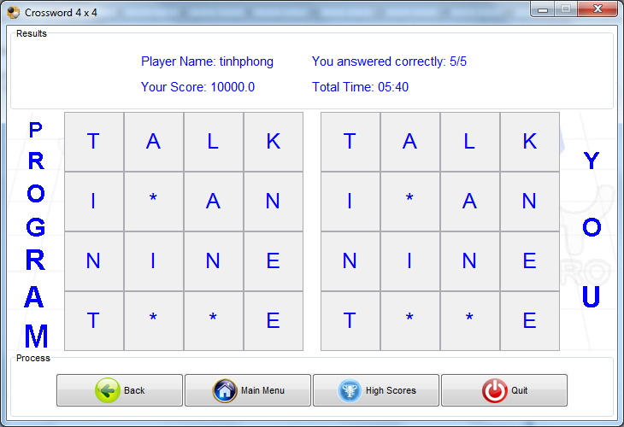
      - Result play 6x6
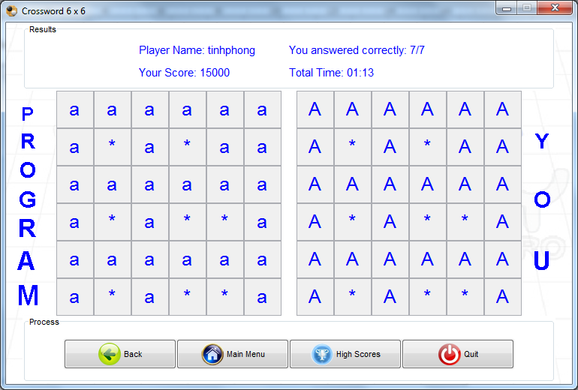

      - Login Form
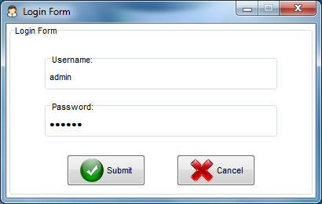
      - Generate puzzle 4x4
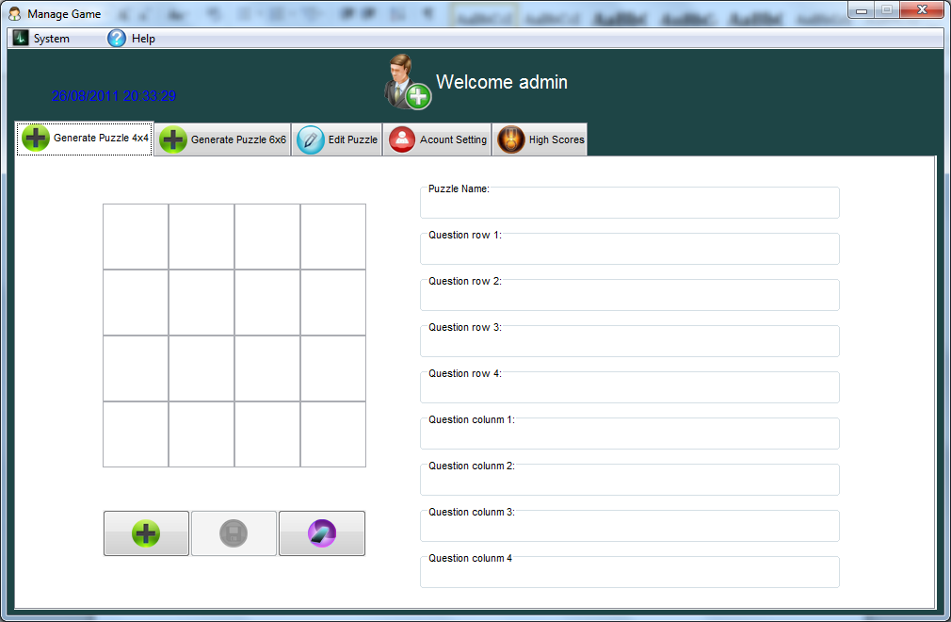
      - Generate puzzle 6x6
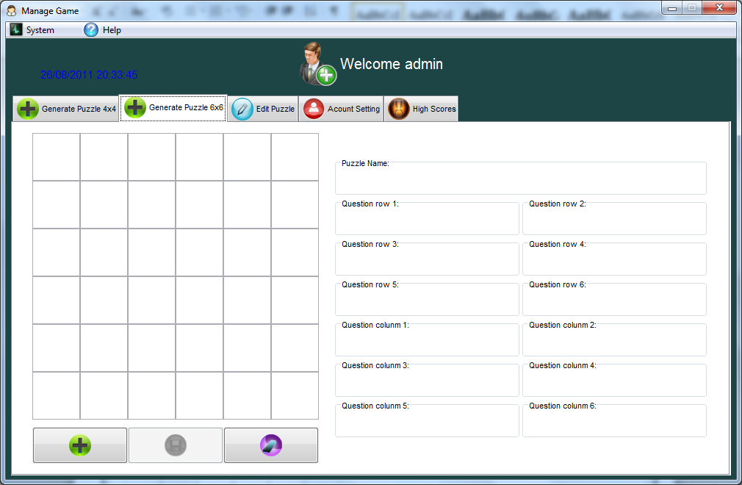
      - Edit puzzle
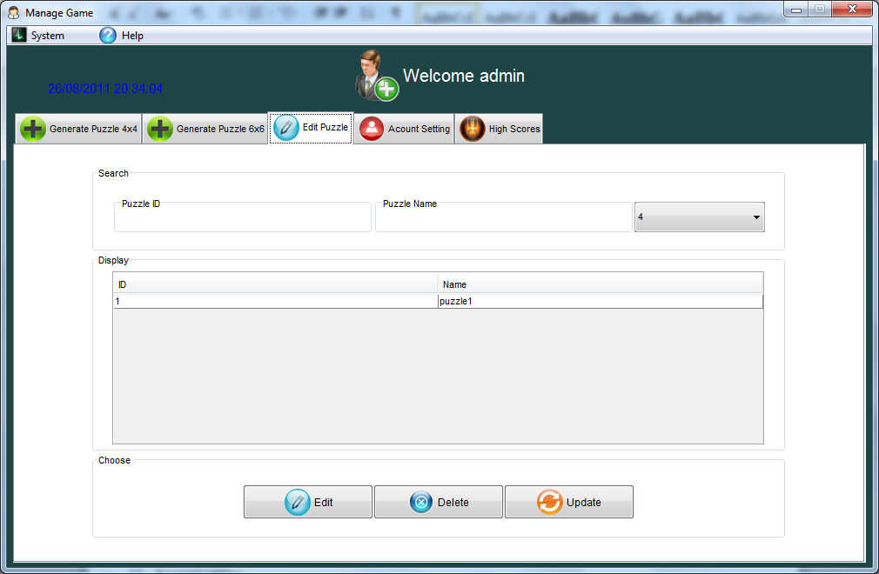
      - Account setting
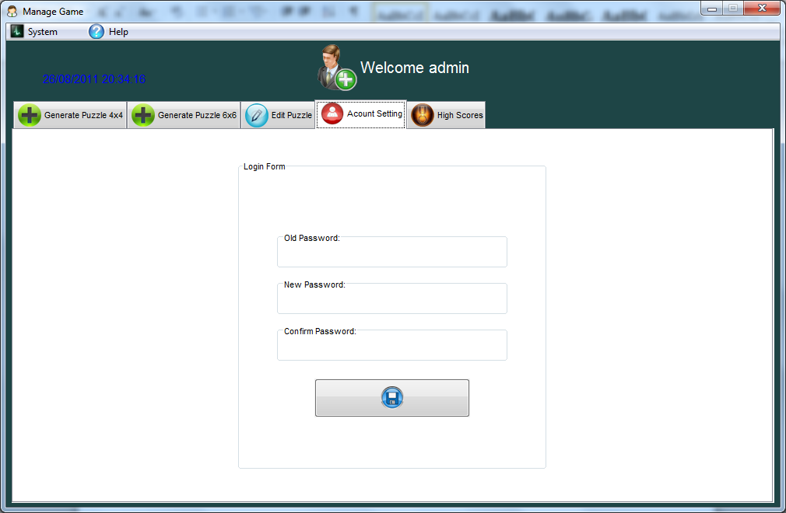
      - High scores
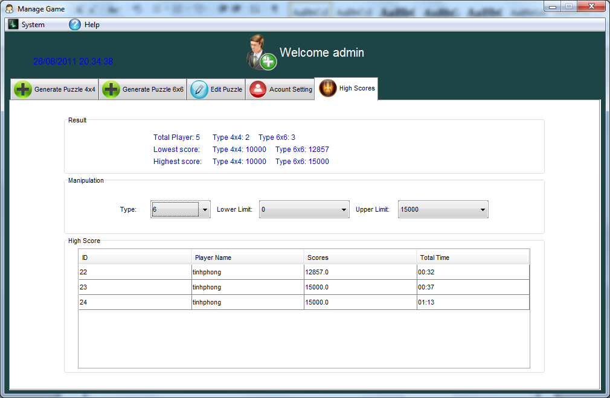
      - High scores user
